
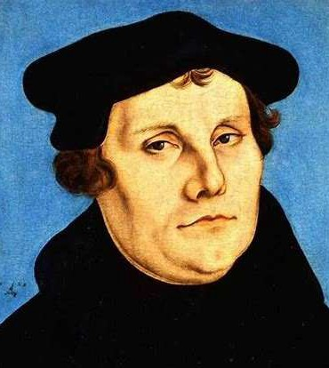
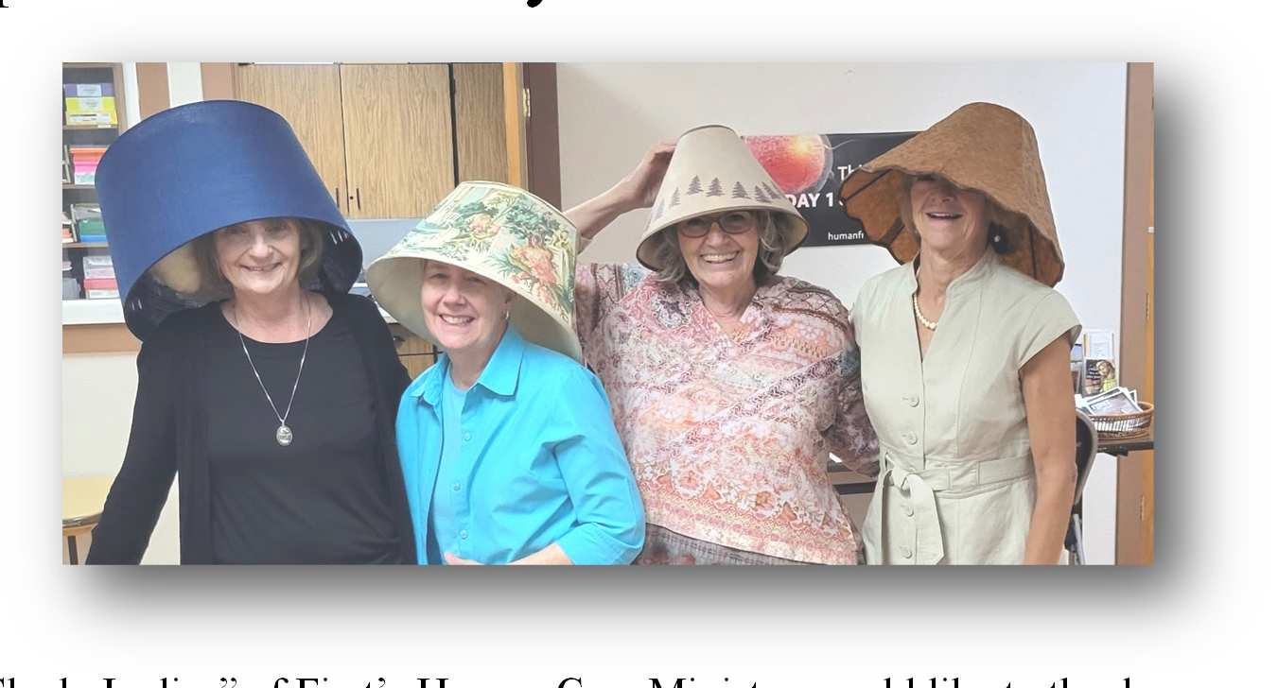
Volume 27, Issue 1
The First Word


FIRST LUTHERAN CHURCH AND SCHOOL — HELENA, MONTANA

October 2025

Seek FIRST His kingdom and His righteousness, and all these things will be given to you as well. Matthew 6:33

Special October Dates
Dorcas Quilters meet Oct. 1

It’s Pastor Appreciation Month

First Edition Book Club Oct. 4
Home of Eileen Burns
LWML Sunday……………………Oct. 5
Cards 4 Kids Fall cards………..Oct. 12 Sale begins!
WOW Bible Study….....………..Oct. 14 Dorcas Quilters meet…………..Oct. 15 OWLS……………………………Oct. 16 Reformation Day (observed)…..Oct. 26 WOW Bible Study…….………...Oct. 28 Dorcas Quilters meet……….….Oct. 29 Reformation Day…..…………...Oct. 31
Pastor Appreciation Month happens every year in October. It is a time when church members come together to show gratitude for their spiritual leaders. Many pastors work long hours visiting the sick, praying for their members, leading worship services, and handling church business behind the scenes. They rarely ask for recognition, but they certainly deserve it.
This month is about expressing thanks in honest and meaningful ways. A kind word, a handwritten card, or a thoughtful gift can lift your pastor’s spirit and remind him how important his work is to the church and to the community.
A pastor’s wife also makes many sacrifices for the church. Acknowledge her efforts and include her in your expressions of appreciation.
Here are some ways in which you can express your appreciation:
- A personal letter or card telling your pastor how his sermon or visit made a difference in your life is one of the most valuable gifts you can give.
- A gift card to a restaurant, coffee shop, bookstore, or gas station is always appreciated.
- A beautiful prayer journal can help your pastor write down prayers, sermon notes, or favorite Bible verses.
- Help him keep his car clean and shiny with a gift certificate for a full-service wash.
- Gift an audiobook subscription, Christian music streaming service, or online Bible study membership.
- A handmade quilt or throw blanket makes a thoughtful and practical gift.
This is a time to reflect on how your pastor’s leadership has helped shape your church family. Pastors spend their lives pouring into others, and this month gives the church a beautiful chance to pour love back into them. Every act of appreciation matters!

our sins is to trust the lie of the serpent that we cannot trust the love and grace of Christ and must take matters into
The sin underneath all
our own hands.
In This Issue
Just show up! 2
The Pastor’s Page 3
“We are all beggars. This is true.” 4
Just for KIDS! 5
Let’s celebrate October birthdays! 6
Happenings at Our School 7


Lampshade Ladies say Thank You!

L to R: DeeDee Spellman, Kris Basinger, Tammy Anderson, and Laurie Stelter
The “Shady Ladies” of First’s Human Care Ministry would like to thank everyone who donated either time and/or items for its Trash to Treasures garage sale held on Saturday, September 13. We could not have done all that was done without all of you.
Our sale earned approximately $4,000, and we will be distributing these funds to our community shortly. God bless you all!


Back to school means sales on cookies! You can help stock up our kitchen pantry with store-bought cookies for our Sunday morning coffee hour!
Lisa Tullis does a wonderful job providing us with delicious snacks, but sometimes we don’t have enough “sweets” and it is helpful to have some in reserve. We appreciate all those who chose to donate over the summer!

Just show up!
In A Million Little Ways (Revell), Emily Freeman says in order for Christians to “show up as you are with what you’ve been given,” we must confront these statements:
  - I’m not cut out for this.
  - Someone else can do it better.
  - People might not like it.
  - I have nothing to offer.
  - I hate my calling.
  - It’s a waste of time.
  - It’s too much work.
  - Who do you think you are?
“A million loud voices … keep us from the million little ways [Jesus] wants to show up through us to the world,” Freeman writes.
— The Newsletter Newsletter


First Edition Book Club members will meet at 9:30 a.m.** on Saturday, October 4, at the home of Eileen Burns. Club members are currently reading — and will discuss — Jayne Eyre by Charlotte Bronte.

Please RSVP to Eileen by Wednesday, October 1, at (406) 475-2265.
In November, members will meet at 9:30 a.m.** on Saturday, November 1, at the home of Joyce Burgett. For this meeting, members will read — and discuss — The Secret War of Julia Child by Diana Chambers.

Please RSVP to Joyce by Wednesday, October 29, at (406) 439-2707.
**Club members are trying something new this year by occasionally meeting early in the morning, rather than at noon. The October and November 2025 meetings, and the March 2026 meeting, will begin at 9:30 a.m. and run until noon. Barring unforeseen changes to the schedule, the remaining meetings will begin at 12 noon.

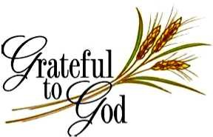
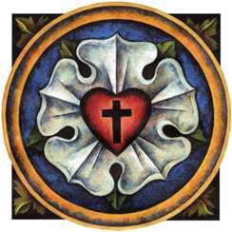
Fall — a great time to read a book!

The First Word
Published monthly by:
First Lutheran Church 2231 Broadway
Helena, MT 59601
(406) 442-5367

Rev. Larry A. Miller Pastor
Linda Fromm Editor
Shari Miller Calendar/Servant Schedule
Volunteer Staff Printing/Collation
Deadline for the November First Word is Wednesday, October 22.
Place articles in the First Word box in the church office
or email to:

A Place in the Promised Land by Darlene Haven is a short, easy-read novel that tells the story of 800 Dutch immigrants who left Holland for religious reasons. It is seen through the eyes of 13-year-old Sarah Spoolstra, who hid in a trunk as a joke and ended up aboard a ship bound for the United States. After discovery, Sarah is looked after by her brother and sister-in-law as she looks for a way to fit into her
new environment.
Spoolstra is the author’s mother’s maiden name, and the author
weaves a credible story around her family history.
This book of historical fiction may be found with many similar volumes in the First Lutheran Church library, which is in the music room. Browse the non-fiction stories and inspirational books on the wall to the left of the piano. Fiction volumes are located on the shelves to the right of the non-fiction section. Both are organized alphabetically by the authors’ last names. Borrow a book and return it when you have read it.
— Bridget Michel

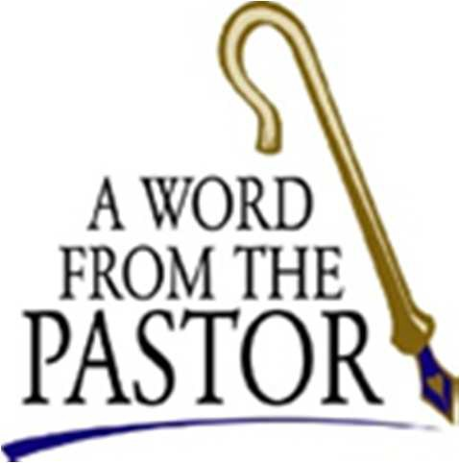
+ Reformation Sunday
2025 AD +
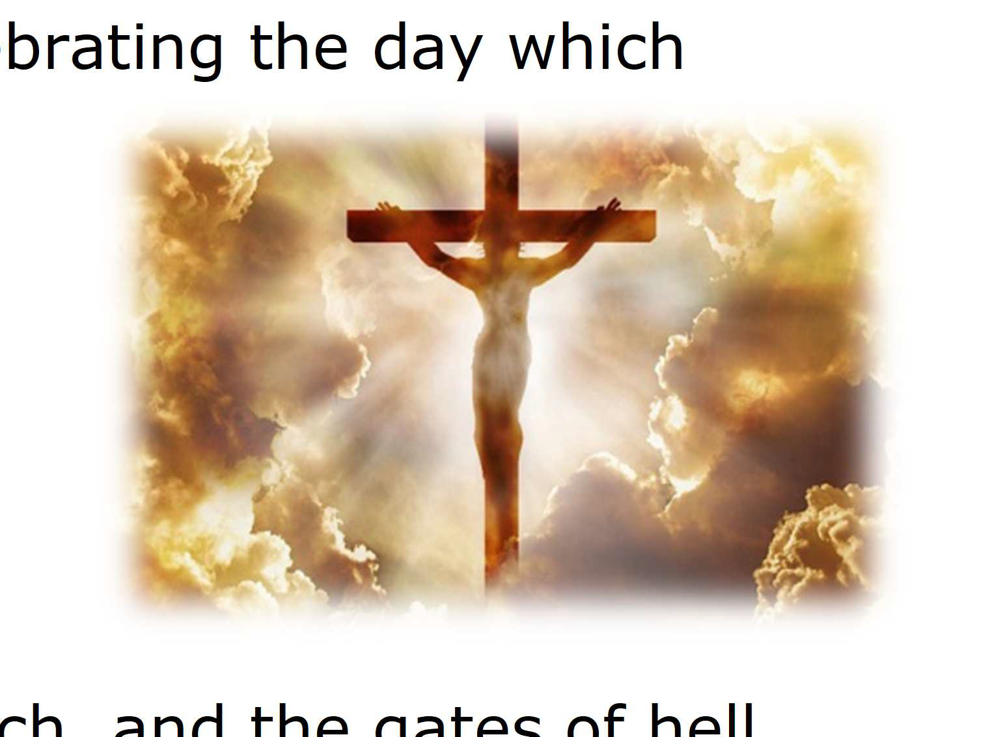
Every year on the last Sunday of October, Reformation Sunday, the Church recognizes and commemorates Martin Luther’s nailing the 95 Theses on the door to the All Saints’ Church in Wittenberg, Germany in 1517. But it’s more than celebrating the day which effectively sparked the Protestant Reformation. We will be
celebrating what that Reformation was actually all about—
the proclamation of the Good News of Jesus Christ:
that we are saved by grace through faith in Him.
That’s what the Christian Church has always been built upon—the grace of God shared with us through Jesus Christ.
After Peter confessed Jesus to be “the Christ, the Son of the
living God,” Jesus said to him, “On this rock I will build my church, and the gates of hell shall not prevail against it” (Matthew 16:18). Through Jesus we have the forgiveness of our sins and the gift of eternal life. No power on earth, nor even the power of the devil himself, can prevail against this gift which we’ve been given.
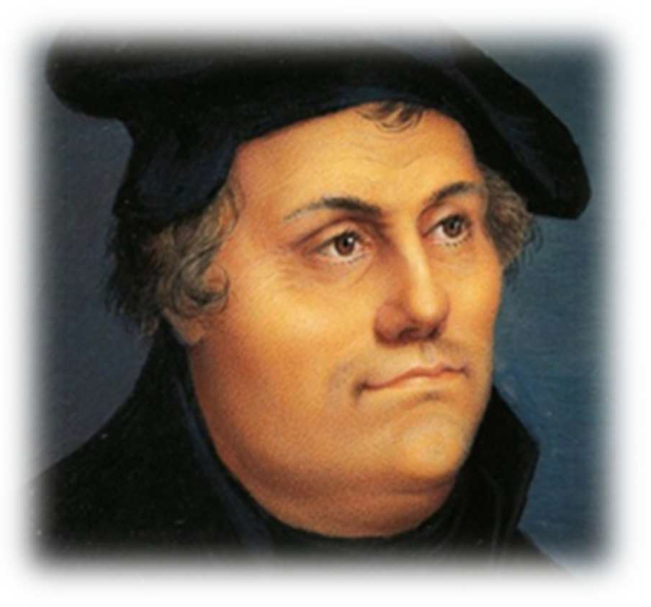
The Church in the 1500’s lost sight of that fact in many ways.
So God used Martin Luther and the subsequent Reformation and other Reformers to remind the Christian Church of the importance of the Gospel. The light of Jesus Christ may have seemed dim, but God was faithful to His promise: His Church will always exist and always prevail. And soon after because of what God had done in their time, the saving light of Christ was seen brightly shining again.
There are days, maybe even some of our current challenging days, when we wonder how bright the light of Christ is shining. Is the Church in decline? What is the future of Christianity? And while we don’t know what the future holds, we can hold fast to the same promise which Jesus made to Peter: that we are built upon the rock of Jesus Christ,
and that nothing in this world will ever prevail against it.

God has made our eternal lives completely secure through Christ.
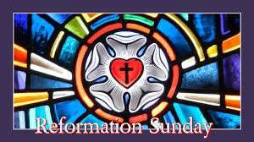
He makes our earthly lives completely secure in Him, as well!

This Reformation Sunday (October 26, 2025 AD), let’s take great comfort in the Good News of Jesus Christ, that we are part of His Church which will always exist and always prevail, and that we will live with our God for all eternity, and rejoice!

Pas+or Miller

“A mighty fortress is our God …
On earth He has no equal.” (LSB 657)

“We are all beggars. This is true.” — from your Board of Stewardship

In the early morning hours of February 18, 1546, Martin Luther closed his eyes forever. Before that happened, the hand that hammered the 95 Theses into the door of the Castle Church in Wittenberg on October 31, 1517, penned its final words: “We are all beggars. This is true.” And this is the truth that our Lord says makes you free.
Ironic, isn’t it? In order to be free, you must be a beggar. You must be utterly dependent and reliant upon God. This makes us uncomfortable – the way we’re uncomfortable when someone gets us a Christmas present when we haven’t gotten them one. We feel we owe them. And we don’t like being in someone’s debt like that.
But what Luther would remind us is that we are all indeed beggars. And we’re not just anyone’s beggars.
We’re God’s beggars. Christ came for sinners. He came to seek and save the lost. He came to heal the sick and raise the dead. He came for sinners, and He dwells only with sinners.
If we are to be where He is, we must be willing to be counted among the lost, the sick, and the dead. We must be willing to be beggars. We must cry out for mercy, for grace, and for His undeserved love and kindness. We
must be dependent solely on Him and what He gives.
And here’s the beauty: He gives us everything. Everything. Forgiveness of sins, salvation from death and the devil, and eternal life. This isn’t because of any worthiness or merit in

us. It is because of His divine goodness, mercy, and grace. On account of Christ’s death and resurrection, the Father forgives you, saves you, and is pleased with you. You receive His love, His righteousness, His holiness, His acceptance, and His inheritance. We are all beggars. This is true.
This is the heart and soul of Christianity and the lifeblood of the Christian Church. God justifies us and
declares us innocent and righteous by His grace received through faith for the sake of Christ. This isn’t because of our works but because of His work on the cross. We, who once were enemies of God, are reconciled to Him and made to be His children.
This is what Luther pointed us to when He took up his pen for the last time and scribbled “We are all beggars. This is true.” We are beggars, but we are beggars of the God who does not ignore us and who doesn’t pass by us on the other side. We are beggars of the One who descended from heaven to make His dwelling with sinners.
We are beggars of Him who deigns to dwell with us, among us, and – yes – still in us by grace for Christ’s sake. For in the bread and cup that we bless, we share together with Christ and each other the riches of God’s grace.
The riches of this grace – the Gospel in sermon and absolution, in Baptism, and in Holy Communion – are so inexhaustible that our cups overflow. We, who are God’s beggars, are inexhaustibly satisfied, and we have something to give back in thanksgiving and praise.
— LCMS Stewardship Ministry


Christian Symbol
VERBUM DOMINI MANET IN AETERNUM — Latin for “The Word of the Lord Endures Forever,” this motto of the Lutheran branch of the Protestant Reformation comes from
1 Peter 1:25. Frederick the Wise, ruler of Saxony and one of Martin Luther’s earliest and most influential supporters, had the VDMA symbol sewn into the right sleeve of the official garments worn at his court. The symbol also appeared on banners, flags, swords, and
uniforms, representing the unity of the Lutheran laity in standing firm in their faith.
— The Newsletter Newsletter

God’s left hand








A 6-year-old and his grandma went for a walk one autumn day. “Look at the gorgeous leaves!” Grandma exclaimed. “Just think, God painted each one of them just for us!”
“Yep,” said her grandson, “and He did it left-handed.”
Perplexed, Grandma asked, “Why do you think God used His left hand to create all this beauty?” “Because,” said the boy matter-of-factly, “we learned in Sunday school that Jesus sits on God’s right one.”



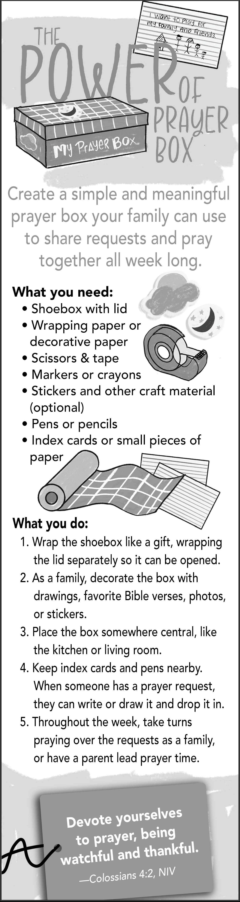

Special cards help to celebrate Fall holidays
Autumn is here and time to greet friends and relatives far away with a Halloween or Thanksgiving card to let them know you are thinking of them!
Packs of Fall themed cards will be available for purchase beginning on Sunday, October 12, in Ziegler Hall. Sale proceeds go to our youth programs and activities here at First Lutheran.
Many thanks to those of you who support this ministry!
— Janice Larison


Cards 4 KIDS

Images shown are for illustrative purposes only. They are not actual card designs.

Celebrating LWML Sunday
Everything we do as Lutheran Women in Mission begins with Christ’s message of repentance and forgiveness.
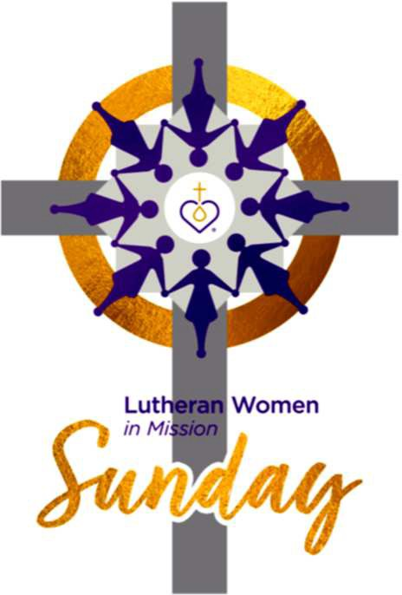
The Ascension text of “GO” (Luke 24:44-53) is the mission emphasis for Lutheran Women in Mission Sunday 2025. On Ascension Day, Jesus gave His followers an assignment “that repentance and forgiveness of sins should be proclaimed in His name to all nations.” We have a responsibility to proclaim the message of Christ, repentance and forgiveness, as we show the merciful Christ in what we do and say. As
Lutheran Women in Mission, we support, encourage, and uplift missionaries, as well as provide physical support and compassion to all people. This proclamation of repentance and forgiveness of sins in Jesus’ name motivates us to do this work. All glory be to Jesus!

— Rev. Mark Maas LWML Senior Pastoral Counselor


October Birthdays

October 2
Korbyn Jurenka
October 5
Rhaely Alexander
October 6
Julia Warsinski

October 7
Arthur Worthy
October 8 Paul Taylor Ross Veach Kathy Winslow
October 10
John Champagne Paul Lanter Charles Olson
October 11
Maddox Rickman
October 12 Larry Miller Clark Spranget
October 13
William Staffeldt
October 15
Cheryl Brown
October 16 Alexander Balcerzak Steven Johnson Melanie Middlebrook
October 18 Owen Carson Peter McCarthy
October 19
Gale Everson Abigail (Abby) Wood
October 22
Natalie Baumann
October 23
Marvin Blokzyl Jr.
Chris Frank
October 24
Jeff Huotari Christine Lanter Norma Jean Walker
October 25 Sharon Carson Isla Johnson Madison McCarthy Olivia McIntosh
October 26
Javri Pearson
October 27 Cassie Cooper Mathieu Lebahn Philip Tullis
October 28 Rachel Blair Caden Stockburger
October 29
Ryan Hanson
October 31
David Johnson







Happenings at First Lutheran School

Director Shannon Champagne
Get Set Teacher Shannon Champagne
Pre-Kindergarten Teacher Lori Radtke
After Care Provider Emily DuPre
Lunch Assistant Jeannie Hubbard
Pastor Larry A. Miller

Meet our 2025-26 First Lutheran School students
We asked our students, “What is your favorite thing about school so far?” Here is what they said.

Get Set Class
Beau: Showing toys. (He expanded this to mean he likes to be shown new toys.)
Charli: Snack time.
Eli: Playing with my new friends, and Colter.
Jane: Playing. The house is best. I like the dolls.
Lola: These books. (She pointed to the Disney Princess
books that can be read aloud.)

Pre-K Class
Clyde: I like the red station.
Colter: I like playing with my friend. We play barnyard. There’s rhinos living with dinos.
Dean: STATIONS! I like orange station. I play lemonade sell.



Ember: I have a new school. I like to do the monkey bars on the ladders. I like to be upside down.
Kasen: Doing the Snapo set. It’s hard. It’s fun. I like the seesaw.









Lily: I liked making the world’s biggest bracelet. It was easy.



Watch the large bulletin board in Ziegler Hall for pictures of our students doing their favorite things.
You can also check out our school newsletters on the church’s website: www.firstlutheranhelena.org

First Lutheran Church & School 2231 Broadway
Helena, MT 59601
Phone: (406) 442-5367
Fax: (406) 442-5285
School Phone: (406) 442-6913 Website: www.firstlutheranhelena.org
Email: churchoffice@firstlutheranhelena.org

NON-PROFIT ORG.
U. S. POSTAGE PAID
HELENA, MT PERMIT NO.
127
FIRST LUTHERAN CHURCH is a Congregation of The Lutheran Church—Missouri Synod
THE MISSION of First Lutheran Church is “Sharing God’s Word with Everyone, Everywhere!”

Tune in to “The Lutheran Hour”—Sundays at 8 a.m. on the Christian Satellite Network 91.1-FM
or listen on “Family Talk” on Sirius XM 131
“Woman to Woman”—Sundays at 9:30 p.m. on KMTX 105.3-FM

Faithful women of the Reformation — Deaconess Betsy Karkan

When asked to make a list of notable women of the reformation, it is not surprising that most of the lists people come up with look something like this:
Katie Luther
……….

If your list bears any resemblance to the one above, know that you are in good company. Katie Luther, while arguably the most famous of the women of the Reformation, is not alone. She stands with many faithful women from the time of the Reformation who were called by God to various vocations in which they were able to serve the home, society, and church.
A brief look at a few of their stories shows the diversity of their backgrounds and how God used them in a variety of ways to bless His Church.
Elizabeth Cruciger, like Katie Luther, was a nun who converted to the Lutheran faith through the writings of Dr. Luther and escaped the convent to live with the Bugenhagens in Wittenberg. She has the distinct privilege of being known as the
first female Lutheran hymn writer and poet. In addition to being a close friend of Katie Luther, it is believed that Elizabeth sat at Dr. Luther’s table talks in Wittenberg with her husband Caspar Cruciger, a theologian friend and colleague of Luther’s. Living in Wittenberg, hearing the pure preaching of God’s Word, and sitting at the feet of the Reformation’s foremost theologians, she was inspired to write the text to our beloved hymn, “The Only Son from Heaven” (LSB 402).
Another Elizabeth, Elizabeth of Brunswick, a daughter of German nobility, was married at a very young age to Eric I, Duke of Brunswick-Luneberg. She was introduced to Luther and his teachings by her mother and came to know him well through regular correspondence.
Eventually she received the Eucharist in both kinds thus declaring her conversion to the Lutheran faith. Although her husband remained a part of the Roman Catholic Church, he did not oppose her conversion as her father had so harshly opposed her mother’s. Following Eric’s death Elizabeth ruled as regent for her young son in
addition to having a rather significant inheritance for herself as a result of their marriage. Her ruling power and influence were instrumental in the establishment of the Lutheran Church in Lower Saxony to this day.
Together, these women were faithful in the unique vocations God had given them as women to live as His baptized daughters in Christ. They supported the Reformation and the Church by serving the Lord as faithful wives, daughters, mothers, benefactors, rulers, writers, and musicians. Like all the saints who have gone before us, we give thanks to God for these faithful women and the gifts they gave to the Church and we pray that the Lord would teach us to follow their examples of piety, service, generosity, faithfulness, and obedience to His Word.

— Deaconess Betsy Karkan served at Concordia University-Chicago when this article was posted on the lcms.org website on May 13, 2016.

