Volume 25, Issue 7
The First Word
FIRST LUTHERAN CHURCH AND SCHOOL — HELENA, MONTANA

May 2024

Seek FIRST His kingdom and His righteousness, and all these things will be given to you as well. Matthew 6:33

Second call for nominations for open positions on Mission & Ministry Council
Special May Dates
Dorcas Circle Quilters meet May 1
Blessing of the Quilts at worship service
First Edition Book Club May 4
Home of Pam Tudor
Sixth Sunday of Easter May 5
Blessing of the Quilts at worship service Dorcas Circle Quilters meet May 8
Ascension of Our Lord May 9
Seventh Sunday of Easter May 12
Mother’s Day
W.O.W. Bible Study May 14
Lifelight: The Parables of Jesus
Dorcas Circle Quilters meet May 15
O.W.L.S May 16
Pentecost May 19
Rite of Confirmation
Trinity Sunday………………………, May 26
Memorial Day May 27
No FLS classes; church office closed
W.O.W. Bible Study May 28
Lifelight: The Parables of Jesus


In preparation for the annual Voters’ Assembly meeting, which will be held in June, MMC President Jason
Mercer has issued a second call for nominations for officers and MMC at-large members to be elected at that meeting. The list of nominees will be closed at the time the meeting agenda and slate of candidates is distributed prior to the meeting.
Nominations are still open
for the office of Vice-President (2-year term); Treasurer (2-year term), and two
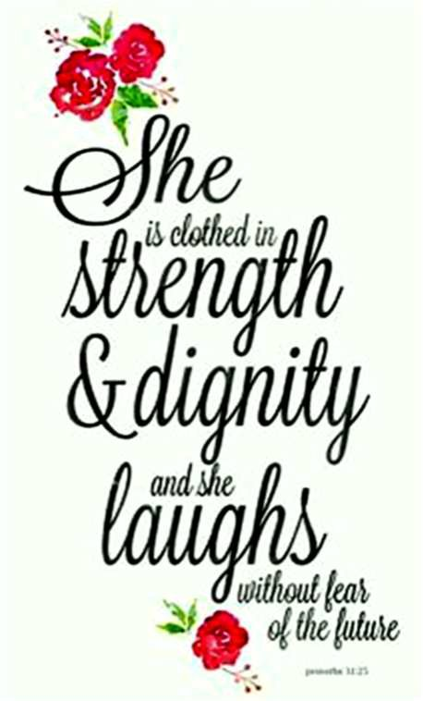
at-large members (each for a 2-year term). All terms begin on July 1, 2024. The office of Vice-President may be occupied only by a male voting member of the congregation (a voting member is a confirmed member, 18 year of age or older). Basic duties of the Vice-President include presiding at all meetings of the MMC and/or the congregation when the President is absent, or when requested by the President to do so; initiating counsel with the President should a violation of policy occur; and leading the nominating committee for the election of officers and
members of the MMC. The
Vice-President does not automatically
move into the office of President.
Basic duties of the Treasurer are overseeing the financial records of the church; suggesting solutions for financial decisions regarding the church budget; preparing and presenting an annual church budget (spending
plan) to be presented to the congregation at the annual voters’ meeting; and being familiar with the church’s Constitution and Bylaws.
Members of the MMC may not serve on other boards or committees of the church. The MMC generally meets one evening each month, for approximately two hours.
If you feel that God is calling you to share your gifts by serving in one of these positions, please contact Jason no later than Sunday, May 19. He may be reached by phone at (406)438-1182, or by email to: jmercer@m-m.net.


Meet First’s new Director of Education

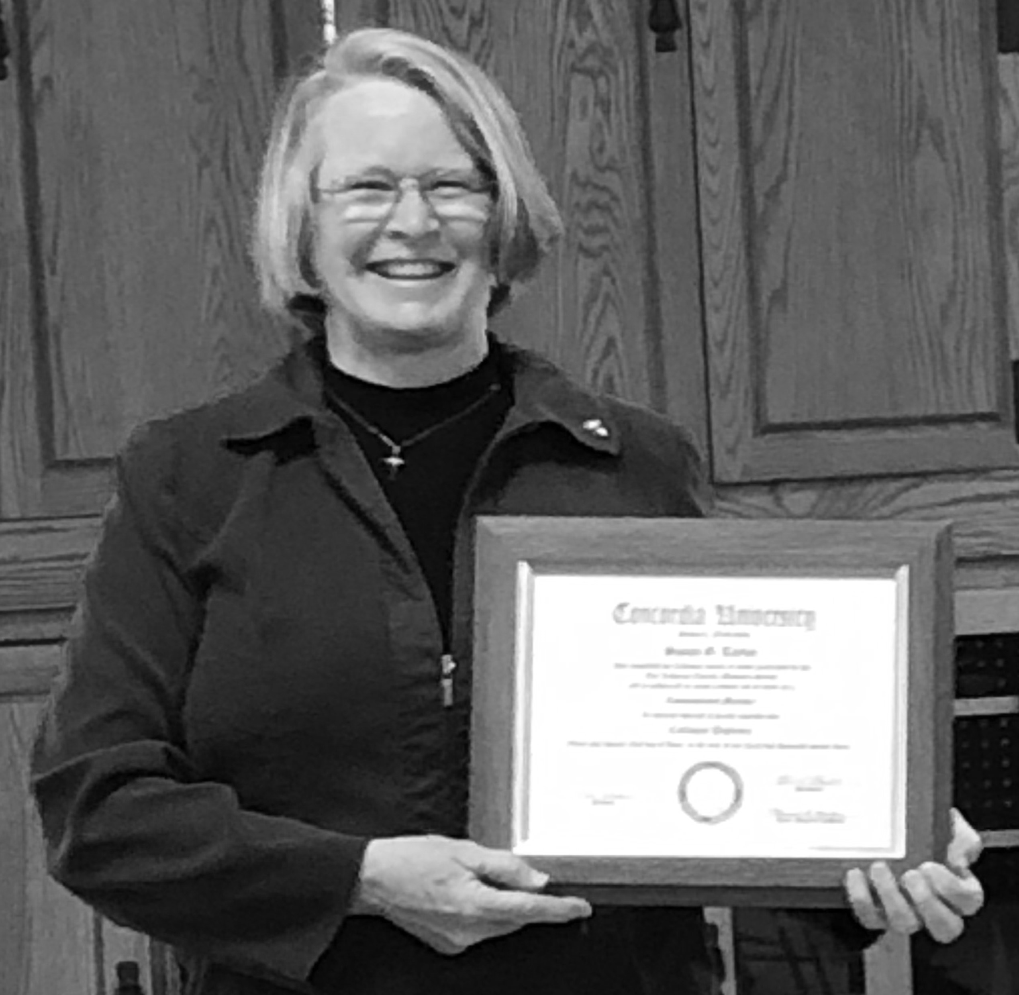
April 14 was an extra special day for Sue Taylor and First Lutheran Church and School. On that day, Pastor Miller installed Sue as the congregation’s
In This Issue
Director or Education (Cont’d) 2
An idea whose time has come
The Pastor’s Page 3
Save the date 4
“It’s a wrap” for quilters
Just for KIDS! 5
Let’s celebrate May Birthdays at First! 6
Calling parents of graduating seniors Happenings at Our School 7
new Director of Education, the culmination of many, many hours of study and a final interview process, which made her eligible to be a called church worker in the LCMS.
The congregation voted unanimously at
a special voters’ meeting on January 24, 2024, to issue a call to Sue as Director of Education, and she accepted the call.
Editor Linda Fromm asked Sue to write a bit of history about her experience with the colloquy process, and why she decided to proceed with the program.
Sue wrote:
In June 2020, First Lutheran Church and School was looking for a new principal/director for the preschool being re-opened. For a few weeks, I read the announcement on the screen and heard a call, but did not respond.

See DIRECTOR, Pg. 2

Director
Continued from Pg. 1

Eventually, I did respond, mainly because our children, Megan and Thomas, attended First Lutheran School during their elementary years. With Miss Heather McIntosh as their teacher, they learned all the essential academic subjects, but, most importantly, connected with God’s Word every day.
Because I had earned my master’s degree, been a teacher for over 20 years, and run a private business for 10 years, I thought I would have the skills necessary to help the school become
re-established. I thought I could spend a year or two to get things rolling and then hand the position to another.
Therefore, I applied and was hired for the position. The 10-hour-per-week work schedule, appointed during the first year, made it challenging to meet the needs of the school, while working through the continuing COVID concerns. However, with the very able hands of Mrs. Lori Radtke in the classroom, the support and direction of Pastor Larry Miller in administration, and the will of God, we had a successful first year.
Going into the second year, I had become aware of the concerns of some members about the absence of called
workers in our school. Although I knew we were sharing God’s Word, it seemed that there was something more that could make our mission more successful. One day, Shari Miller asked me if I would have any interest in attending the colloquy program.
Honestly, I had no idea what the colloquy program was, but said it sounded like something that I might be willing to try. Further investigation led me to discover that this program, provided through Concordia University System, provides the education needed to be eligible for
a call in The Lutheran Church— Missouri Synod. The colloquy program prepares the teacher/ administrator to carry the Lord’s name and His teachings with faithfulness to the children and their families.
Through a series of courses in Old Testament, New Testament, History of Theology, Christian Doctrine, Lutheran Confessions, Varieties of Beliefs, and the capstone courses of Lutheran Teacher 1 and 2, the church worker is educated in theology and becomes oriented to service to the Synod. I enrolled in the program in response to His call. Through the completion of these courses, the submission of a confession of faith document, and an exit interview with staff at Concordia University-Seward, I was prepared and deemed eligible for
a call.
While I completed the courses, my family was patient as I divided my attention between being a wife, a mother, a daughter of an aging mother, a business owner, a student, and a principal. The years were busy, the days were long, and the expectations were high. However, the honor of being a child of God and the opportunity to live in His Word made it all worth it. It has been a blessing to have the opportunity to study God’s Word, learn how to serve, and share the message of God’s love and mercy. It has been a journey from the business woman who wanted to help a school, to the servant who is called to minister to children and their families. It is a gift to be provided the fortuity to serve at First Lutheran Church and School.
Thank you to the congregation which has stood beside me on this journey.
Thank you to each of you who have shared words of encouragement, smiles, hugs, cards, and prayers. Thank you to my family members who have been patient and supportive. Most of all, thank you to God, who, through His love and mercy, has given me faith and has led me to serve in His name.
For more information about the
colloquy program, please go to the following link: https://www.lcms.org/colloquy-ministers- of-religion-commissioned

“Burnt toast is actually fairly symbolic of Motherhood. If you are the one who burned the toast, you scrape it off and eat it yourself. If they burned it, you eat it because they burned it specially for you.”
— Emily Watts

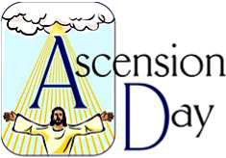
An idea whose time has come

The First Word
Published monthly by:
First Lutheran Church 2231 Broadway
Helena, MT 59601
(406)442-5367

Rev. Larry A. Miller Pastor
Linda Fromm Editor
Shari Miller Calendar/Servant Schedule
Volunteer Staff Printing/Collation
Deadline for the May First Word is Wednesday, May 22. Place articles in the First Word box in the church office or email them to: lindafromm@mac.com
Are you looking to form meaningful connections with other men in the church and have some fun in the process? If so, would you be willing to serve as the organizer for a men’s fellowship event, or — if not the organizer
— be willing to participate in some relaxing activities with other men, perhaps fishing together, attending a sporting event, or simply meeting for breakfast or coffee occasionally? Any of these events would be opportunities for men to get to know each other better; to build lasting friendships with men who share the same values and aspirations; to encourage one another in their walk with God; or to join hands in serving our church and community.
If you would be willing to organize an initial event, or simply wish to participate, please call the church office (406-442-5367) and leave your name and contact information with Shari. It’s our men’s turn to have some fun!


Pastor’s 
a mixture of comments concerning our life together in Christ!

Our Current Adult Bible Class …



Meets each Sunday at about 9:30 a.m. in the Fellowship Centre!

Please join us as we study these
lessons for life!

======================================================

Our Next

O.W.L.S.* Event
will be Thursday, May 16!
Watch upcoming Bulletins and your email box for the details!


*Older Wiser Loving Saints are 55+ish

====================================================
We will welcome new members

Rylan Edlin Michael Johnson Derek Nygaard Jana Nygaard Keith Stromberg

as they profess their faith in Jesus in our Earlier Service
on Sunday, May 12!

Speaking of New Members

Elainah Veach Emma Veach
Ethan Elvbakken Everett Hollatz
Lillian Buhr

will confirm their baptismal faith in Jesus in the Earlier Service on Sunday, May 19.
====================================================
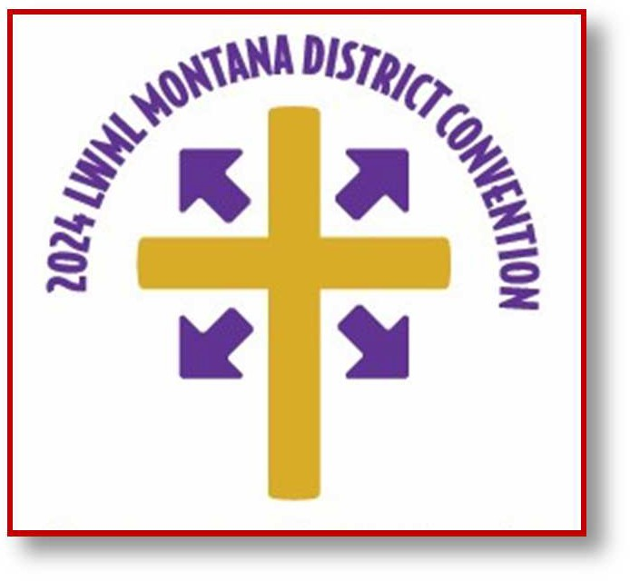
It is possible (perhaps likely) that as you read this 150 or so ladies (and a few men) from across Montana and beyond are meeting in Polson, Montana for the biennial Lutheran Women’s Missionary League
convention under the banner (literally) “Tell Everyone what HE has Done,” based on Psalm 26:7, and sung in Divine Services One and Two in our worship liturgy.
Convention participants have
the opportunity to study, sing, and do the theme: “Tell Everyone what Jesus has Done!”
What if we ALL do the theme? What could happen if every one of us told some one what Jesus has done, in His life, death, and resurrection, and so much more, for us and for our salvation? As the popular Christian song says, “I Can Only Imagine.”

With the ladies of the Montana District LWML, let’s do the theme, tell what Jesus has done, and see what happens! Knowing the Holy Spirit is at work as we tell the Good News of God’s Word, it is bound to be great!
Can you imagine it?
Blessings in your telling,
what Jesus has done,


Save the date!


You are invited to attend the spring fellowship event here at First Lutheran on Sunday, May 5! We will be enjoying a “Sandwich Bar & Movie” after the 11 a.m. worship service. The title of the movie will be announced SOON, so watch your Sunday ANNOUNCEMENTS!
Please sign up on the sign-up sheet in Ziegler Hall to bring sandwich fillings and/or different types of breads or rolls. The Fellowship Committee will provide condiments, sides, beverages, and cake for dessert!



We encourage you to bring family and friends so we can enjoy the beauty of the season and time together.
First Edition Book Club members will meet at 12:15

p.m. on Saturday, May 4, at the home of Pam Tudor. Members are reading a book they have selected from the Maisie Dobbs series by Jacqueline Winspear. Please RSVP to Pam by Wednesday, May 1, by calling or texting 406-439-9719.
Maisie Dobbs author Jacqueline Winspear is scheduled to speak at the Helena Civic Center at 7 p.m. on Monday, May 13. This will be an excellent opportunity for members to get to know her better.
Members will meet at 12:15 p.m. on Saturday, June 1, at the home of Lisa Tullis. Lisa and Susan Buhr will co-host. For this meeting, members will read Thunder and Rain by Charles Martin. Please RSVP to Lisa by Wednesday, May 29, by calling or texting 650-759-5558.
Because both Pam and Lisa live a bit out of town, members who live in town and wish to carpool should watch for further information to come from Linda Fromm.

Wanted: Yummies for Sunday morning coffee hour
Please consider signing up to bring “treats” for the Sunday morning coffee hour and Bible study. Anything savory or sweet would be delicious!
A sign-up sheet is available in the kitchen area and there is space for signatures for the next two months.
Thank you!

Options says Thank You!

Ruth Stelter reports that First Lutheran recently received a Thank You note from Options Clinic, indicating that our congregation’s members raised an amazing $448.10 by filling baby bottles with loose change, currency, or checks during the Baby Bottle Campaign earlier this year.
The Thank You expressed the clinic’s gratitude for First Lutheran members’ help in “offering hope and building families.”

Options offers pregnancy testing, ultrasound exams (free of charge), parenting and life skills classes, and after abortion support (though it does not offer, recommend, or refer for abortion, but is committed to offering accurate information about abortion procedures and risks).
— Your Fellowship Committee

“It’s a wrap” for quilters
The women of Dorcas Circle thank the members and friends of First Lutheran for their wonderful support throughout the year. We received a generous amount of beautiful fabric, sheets, and crochet thread. We thank Thrivent Financial for a $250 grant to buy batting. In addition to the Wednesday morning crew, various ladies cut squares, sewed tops, hemmed quilts, and sewed schoolbags and the baptismal quilts presented to children who are baptized at First Lutheran. Lisa Olson provides the professional scale and her expertise when we pack boxes for shipping. (Check the map on the quilting closet door to see where quilts were distributed in 2023.)
Fifty-four quilts and 25 school kits will go to Lutheran World Relief, and will be blessed during church services on May 1 and 5, packed on May 8, and picked up on May 10. We also donated two quilts to send to servicemen in Hawaii.
For more information about Lutheran World Relief, which has been distributing quilts since 1945, talk to a quilter or go to: lwr.org.
If you would like to sew tops during the summer, please talk to Bridget Michel.
















On mothers …. by their kids
How did God make mothers?
- Magic plus super powers and a lot of stirring.
- He made my mom just the same as He made me; He just used some bigger parts.
- He used dirt, just like He used for the rest of us.

What kind of little girl was your mother?
- I don’t know because I wasn’t there, but my guess would be she was pretty bossy.
- They say she used to be nice.
- My mother has always been my mother and none of that other stuff.

Opportunities abound for First Lutheran Youth during summer months
Director of Education Sue Taylor invites all First’s younger members to join in the following activities planned for this summer:
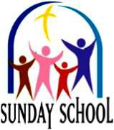
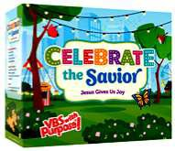
Summer Sunday School classes every Sunday at 9:30 a.m.

Let’s celebrate the Savior at Vacation Bible School July 22-26!
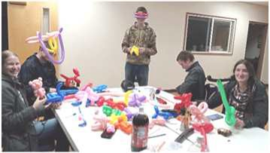
Fun youth group events each month: activities and dates yet to be determined. Please watch the church calendar for specifics.

Ten weeks of summer camps for children ages 5-10. Camps run from 8 a.m.– 4 p.m. each week day, from June 17-August 23.
Following the Lord (FtL) meetings will
continue to be held each Monday evening at 6 p.m.



Calling all parents of graduating
seniors!
If your family includes a high school, alternative high school, or college senior scheduled to graduate this year, First Word Editor Linda Fromm needs your help.
She would like to publish a list of 2024 graduates, their parents’ names, and the high school or college from which they will graduate.
If your student wishes to do so, it would also be great to list his or her plans for life after high school (work, college, travel, etc.).
Please e-mail your information to Linda at: lindafromm@mac.com or put a copy in the First Word box in the church office or in Linda’s mailbox in Ziegler Hall by Wednesday, May 22.

Congratulations to all First Lutheran graduates. May our gracious God go with you as you begin your next big adventure!




May 1 Shaimera Best Chelsey Gochis
Zachariah LaForge
May 2 Dennis Brown Levi Hollatz
William McIntosh IV

May 3
Avery Hollatz

May 5
Mel Kuehne

May 6
Marvin Dye
May 7
Marylin Smith

May 8
Wylie Rucker

May 9
Skyler McIntosh

May 11
Mark Meek

May 12
Kelly Koenig
May 13 Linda Fromm Trenton Sobeck
May 14 Kelly Blackford Russ Warren

May 16
Thea McCarthy Ellie Mercer Cheryl Sobeck

May 18
Randy Sobeck

May 19
Travis Hyyppa

May 21
Thom Warsinski
May 23 Oliver Sieber Jennifer Woehl

May 26
Kolton Hyyppa
May 27 Thelma Gossett Everett Hollatz
May 28 Melissa Miner Shirleen Pape
May 29
Todd Boucher Robert Fox Robert Janes

May 30
Jeanette Talley






Happenings at First Lutheran School

Director Sue Taylor
Get Set Teacher Shannon Champagne
Pre-Kindergarten Teacher Lori Radtke
After Care Providers Pam Worthy/Emily DuPre’
Pastor Larry A. Miller

In honor of Mother’s Day, we have asked our students what they appreciate about their moms. Their responses are priceless and show how much love these little people share.

Here is what our Pre-K students said about their moms.
BECKHAM: “Mommy loves me. She waters plants. She helps me do stuff.”
CHARLI: “I like Momma so much because she is beautiful. I call her Queen Momma!”
EVERETT: “Mommy teaches me basketball skills and does Art Hub with me. Why I love my mommy is because she is funny.”
HOLLYN: “I love my mommy because she is my mommy. She lets me see my cousin sometimes.”
BELLA: “I like it when Mommy takes me bowling. Mommy is nice.”
KADEN: “I love to hug my mommy and snuggle with her. And watch basketball with her.”
PERCY: “I love my mommy so much! She takes care of me by helping.”
PRESLEY: “When I get hurt, my mom comes to me. She gives me my blankie.”
RHYS: “I love her so much. She pulls weeds out of her flower garden right by my window.”
RORY: “Mom always loves me and snuggles me. She really wants to have me in her arms.”






Here is what our Get Set students said about their moms.
JACIE: “I love my mom because she plays with me, and she swings me. I give her flowers I pick from the ground.”
TITUS: “My mom plays with me at parks and she snuggles with me and hugs me, and helps me find caterpillars, and we watch shows.”
ISLA: “My mom hugs and kisses me and cuddles me. She helps me cut with scissors, and I just love everybody in the whole world.”
RAIDEN: “My mommy kisses me, she snuggles me, and she also cleans with me.”
WYATT: “I love my mom because she snuggles with me when it’s bed time, and she watches basketball shows with me, and her plays with me when it’s night time. She always, always colors with me.”
COLTEN: “Fun, yeah. Momma.”
AVRAM: “I like when my mom tickles me.” (He tickled himself to show, and laughed.)
ISAAC: “She always tucks me in and sometimes reads me a story, and she sometimes picks me up. I love her!”
TREY: “I love my mom because she does for me things like getting me clothes and getting me dressed.”
MYLES: “My mom pushes me on the swing and her gets me Transformer things.”

First Lutheran Church & School 2231 Broadway
Helena, MT 59601
Phone: (406)442-5367
Fax: (406)442-5285
School Phone: (406)442-6913 Website: www.firstlutheranhelena.org
Email: churchoffice@firstlutheranhelena.org

NON-PROFIT ORG.
U. S. POSTAGE PAID
HELENA, MT PERMIT NO.
127
FIRST LUTHERAN CHURCH is a Congregation of The Lutheran Church—Missouri Synod

THE MISSION of First Lutheran Church is “Sharing God’s Word with Everyone, Everywhere!”

Tune in to “The Lutheran Hour”—Sundays at 8 a.m. on the Christian Satellite Network 91.1-FM
or listen on “Family Talk” on Sirius XM 131
“Woman to Woman”—Sundays at 9:30 p.m. on KMTX 105.3-FM

More than a negative — from your Board of Stewardship

Even if you’ve never had to testify in court, a thousand TV shows have made you familiar with the question, “Do you swear to tell the truth, the whole truth and nothing but the truth?” Why not just make people swear to tell the truth? Or make them promise not to lie?
Any parent who has ever had to interrogate a child about a broken cookie jar or a scuffle over a toy knows the answer. There are plenty of ways to try to get out of trouble without technically lying. You tell just enough of the truth to skate on by.
We often play the game of seeing how close we can get to sinning without technically going over the line.
But in our heart of hearts we know that this is not what God intended when He gave us the commandments. He’s not giving us a merely negative rule and challenging us to just barely stay away from this or that. There is much more to each commandment than a prohibition. We shouldn’t just avoid murdering people — we should
be of service to our neighbor.
For each negative prohibition in the commandments there is a positive

good that we are to cherish and protect. In the Eighth Commandment, that gift is the reputation of our neighbor and our relationship with him: You shall not give false testimony against your neighbor.
What does this mean? We should fear and love God so that we do not tell lies about our neighbor, betray him, slander him, or hurt his
reputation, but defend him, speak well of him, and explain everything in the kindest way.
Your relationship with your family members (who are your nearest neighbors), the other members of your congregation, your coworkers and your friends is one of the most precious gifts you have been given.
You need to exercise good stewardship with this gift just as much as you need to exercise good stewardship with your life, resources, time and income. This is an especially fragile gift because it’s easy to ruin a relationship with slander and talking behind someone’s back.
But speaking well of your neighbor in Christian love is absolutely free; it costs you nothing, yet it pays you great dividends. If you find this challenging at times, if you are tempted to speak ill of others, just remember that this other person is also a beloved child of God for whom your Lord Jesus suffered and died. Your Lord Jesus loves you both.
— LCMS.org

