Volume 24, Issue 2
The First Word
FIRST LUTHERAN CHURCH AND SCHOOL — HELENA, MONTANA

November 2022

Seek FIRST His kingdom and His righteousness, and all these things will be given to you as well. Matthew 6:33

Sowing the seed of God’s Word
Special November Dates
All Saints Day Nov. 1

Dorcas Circle Quilters meet……Nov. 2

First Edition Book Club………….Nov. 5 Home of Lisa Tullis

Daylight Saving Time ends…..Nov. 6 All Saints Day (observed)
Church Directory Photo Day

ELECTION DAY………………...Nov. 8 WOW! Mountaintop Journeys
Bible Study

Veterans Day…………………...Nov. 11 Dorcas Circle Quilters meet…..Nov. 16 OWLS…………………….……..Nov. 17 Christ the King Sunday…….….Nov. 20
WOW! Mountaintop Journeys...Nov. 22 Bible Study
Thanksgiving Day……………...Nov. 24 First Sunday of Advent………..Nov. 27

For many years, the ministry of First Lutheran Church has included
support of the spiritual growth of the
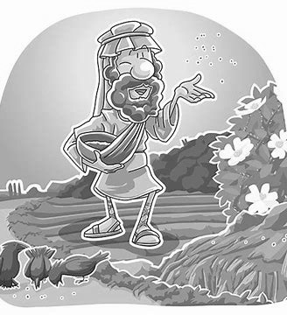
residents of the Boulder River School for the Developmentally Disabled. As the population of the school
diminished due to
legislative action, the opportunity for ministry grew! The facility is now named the Boulder
Intensive Care for the Disabled, home to 12 residents. On Tuesdays, Lowell Bartels and Gail Kortman minister to the patients and staff at this facility.
A new door opened to God’s Word at the men’s infirmary in Boulder. The 25 men at the infirmary were inmates at the prison in Boulder until they required
continual medical attention. The men in this facility attend regular worship services with Lowell and Gail each Tuesday.
The good seed of God’s Word is also being planted at the Elkhorn Women’s Rehab Center in Boulder. The 40 women
who live at Elkhorn were imprisoned until they agreed to treatment to give up their
addictions. Many of these women attend Tuesday afternoon Bible study for
worship in the Word and song.
At First Lutheran Church, we continue to serve our disabled community through God’s Word each Sunday. This
continuous ministry was launched in 1977 (45 years ago!) and has
evolved over time. What began as a separate service in the afternoon in the sanctuary inspired the construction of the chapel in the basement where worship takes place
every Sunday morning at 11
a.m. Our church bus leaves
every Sunday morning at 9:30
a.m. to pick up residents from our community group homes. Our team of servants includes
Steven Johnson, Dan McGrane, John and Shannon Champagne, Joyce Nachtsheim, and Gail Kortman. Our ministry also includes the Christmas pageant and Dinner—including gifts from our
congregation—and providing space for weekly social gatherings on Thursday evening.
Thank you to all of you who support and encourage the ways we are sowing the
seeds of God’s Word!

— Lowell and Susan Bartels

REMEMBER . . .
Set your clocks BACK one hour when retiring on Saturday night, November 5!

How sharp is your Bible knowledge?
Can you find 16 books of the Bible hidden in the paragraph below? Give it a try!
(Answers will be published in the December issue of The First Word.)

I once made a remark about hidden books of the Bible. It was a lulu. Kept people looking so hard for facts...and for others, it was a revelation. Some were in a jam,
In This Issue
The steward is accountable 2
The Pastor’s Page 3
Just for KIDS! 4
It’s beginning to look a lot like Christmas 5
Let’s Celebrate November Birthdays! 6
Happenings at Our School 7
especially since the names of the books were not capitalized. But the truth finally struck home to numbers of our readers. To others, it was a real job. We want it to be a most fascinating few moments for you. Yes, there will be some really easy ones to spot. Others may require judges to help them. I will quickly admit it usually takes a minister to find one of them, and there will be loud lamentations when it is found. A little lady says she brews a cup of tea so that she can concentrate better. See how
well you can compete. Relax now, for there really are sixteen names of the books of the Bible in this paragraph.

— Marty Baumann

The steward is accountable

— from your Board of Stewardship

“Blessed is everyone who fears the Lord, who walks in His ways! You shall eat the
fruit of the labor of your hands; you shall be blessed, and it shall be well with you” (Psalm 128:1-2).

Fear, faith and stewardship. Three things that go together. And it isn’t because you can have faith that any talk of stewardship will create fear in the hearers! These three
seemingly unique topics go together because they flow from the same source—the Lord Himself.
Created by God, the steward is
accountable. This accountability was originally without fear. The steward worked and kept (GEN. 2:15) the
creation called into existence by the Lord. That arrangement lasted until sin came into the equation. Then fear came with it. Adam and Eve hid from their accountability in fear of the
Lord. To fail as a steward in this way deserves death. From that moment on,
as stewards they would never fully measure up. Death is the lasting
legacy.
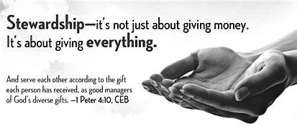
Until Jesus! When the simple gift of Jesus is offered in the babe of
Bethlehem and the Christ of the cross,
fear gives way to faith. Jesus took
accountability for our failed
stewardship and we were restored. Baptized into Christ, the Holy Spirit creates faith which leads to a
restoration of faithful stewardship! Set on this new path the steward’s accountability is balanced between fear and faith. We know that we are
accountable to live and work for the
Lord. When we succeed, it is to God’s credit. When we fail, our faith in
Christ leads us to confession and
absolution, which once again sets us on the path of faithful stewardship.
This use of God’s simple gifts is
captured in the words of the psalmist. Fear of the Lord leads to work. Work leads to blessing. Faith sees this
blessing as a gift from God. The baptized steward sees this and clearly confesses that it is indeed well with us. May the Lord lead us to this triune stewardship of His simple gifts!

Prayer:
Lord, as Your stewards, we work in fear of our shortcomings and sin, in faith in Christ’s redemption and restoration and eager desire to serve as faithful stewards of Your simple gifts. Lead us by grace through faith to see, rejoice and serve in this faithful stewardship! As you have blessed us with Your work in Jesus, may our work as stewards be a blessing to others. Amen.

— This article is taken from Simple Gifts, a series of LCMS Stewardship Ministry devotions. Used by permission.

First Edition Book Club members will meet for lunch at 12:15 p.m. on Saturday, November 5, at the home of Lisa Tullis. Members are currently
reading—and will discuss—The Tea Girl of Hummingbird Lane by Lisa See.
Please RSVP to Lisa by Wednesday, November 2, at 650-759-5558.
The December luncheon and discussion will be held at 12:15 p.m. on Saturday, December 3, at the home of Bridget Michel. For the December meeting, the group will read—and discuss—Gideon’s Gift by Karen Kingsbury.
Please RSVP to Bridget by Wednesday, November 30, at 406-438-6214.

Why legible writing is important
When you write a check for your church offerings, your check is ultimately electronically scanned, copied, and digitized by the bank prior to deposit. Sometimes, if the
check information is not clear or legible, the electronic bank scanners do not accurately scan the information on your check. This can delay deposit and processing of your check. As a gentle reminder, if you must write a check for your offering, please ensure that you write clearly and
legibly, so the electronic check scanners can accurately record your check information. This will ensure accuracy both for our church deposits, as well as for your personal bank statements. Thank you.
— Jerry Michel

A report from your Board of Finance

September 2022 FY 2023 Y-T-D Income (Church & School) $ 53,570.54 $144,041.33 Expense (Church & School) $ 42,575.92 $139,281.31 Gain/Loss $ 10,994.62 $ 4,760.02

The First Word

Published monthly by:

First Lutheran Church 2231 Broadway
Helena, MT 59601
(406)442-5367

Rev. Larry A. Miller Pastor
Linda Fromm Editor
Shari Miller Calendar/Servant Schedule
Volunteer Staff Printing/Collation

Deadline for the December First Word is Wednesday, Nov. 23. Place articles in the First Word box in the church office or email to: lindafromm@mac.com

Volume 24,Issue 2 The First Word-November 2022 Page 3

Pastor's f•Ji, ...
amixture of comments concerning our life together in Christ!

of.£,CJJ,u.ti,O
135years (of our congregation)
175 years (of the LC-MS)
SOS years (of the Reformation)

On Sunday, October 30!.
@8:15 a.m, @11 a.m., @4 p.m.

BIBLE
WotJLpwi& eit,...

Thrutksg wtn.g eve
November 23 ~ 12: 10 / 6: 30 p.m.

Christ the Ktn.g SlAJ'lllay
-

November 27 ~ 8: 15 / 11 a.m.
01.U' fkk,e,nt Mitlwoo Serte.s

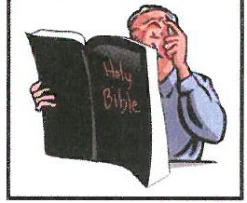
Our Next
Adult ,llible lass

"Wi.se.
Words"
STUDY

begins November 30 ~ 12:10 / 6:30 p.m.

"Give T/ia,,,ks - to the Lord, for He is good, for His steadfast love endures forever."
- Psalm 136:1-

Begins November 13
Meets each Sunday at 9:30 a.m.
In the Fellowship Centre!

Please join us as we study
the "proverbial" Bible book ~ Proverbs!

Our Thanksgiving-Month
O.W.LS.• 8-ve.nt
will be
Thursday,
November 17!

4LW4 df-d!-
Watch upcoming Bulletins and your email box
for the Thank-full details!

*Qlder Wiser l,oving S.aints are SS+tsh
What great reasons we have to give God thanks!

He has gifted us with His creation, everything He has made,
that we might live in it and care for it, and enjoy it!

He laid down His life, and died, so that we can live, really live, and so that we can love
tl
Him and one another!

He has called us to faith,
and made us members of His family, and gathered us together as His church, and will keep us as His own,
until He takes us home!

This thanks-giving and living month, let's do it!

for the cards, greetings, gifts for Pastor's Appreciation Month!

Your love and support
is precious and so encouraging!

'Pas+or}<fj/u

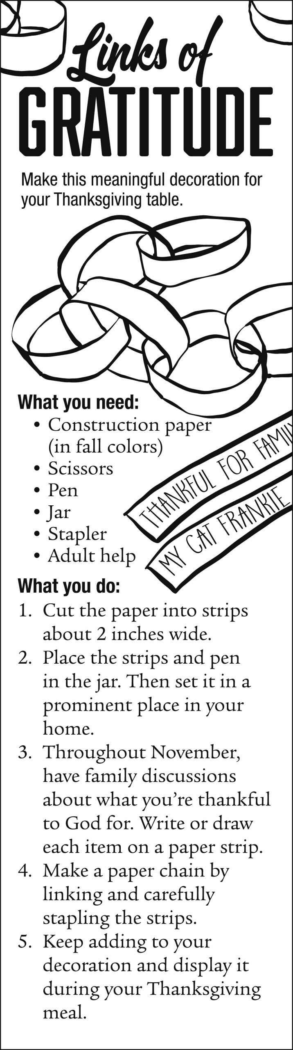
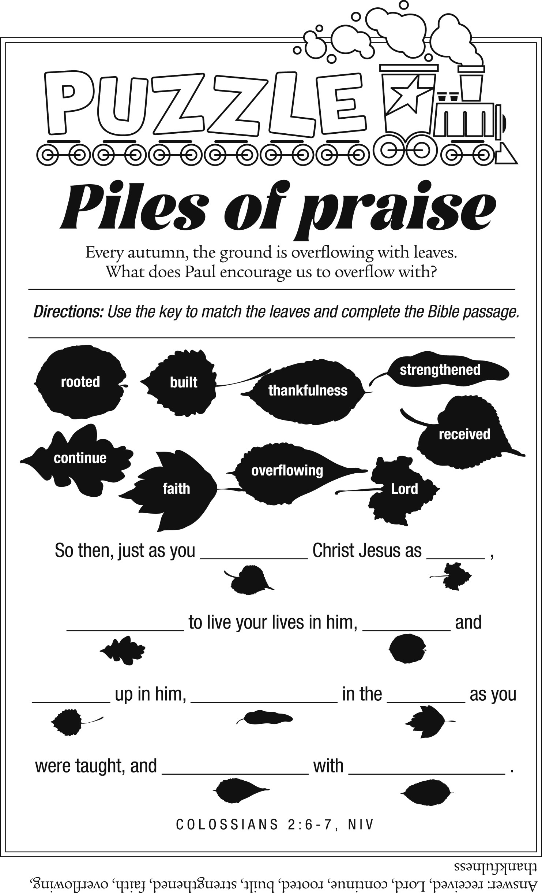
Page 4 The First Word—November 2022 Volume 24, Issue 2

Volume 24, Issue 2 The First Word—November 2022 Page 5

It’s beginning to look a lot like Christmas . . .

scoop.
Oooopppps! It’s still November!
Sorry to rush
ahead, BUT we know how
many of you like to do your Christmas shopping in
advance, so
here’s the
narthex after Thanksgiving. Please select an ornament from that tree for each gift-wrapped robe you purchase. Our goal is to provide each person from the 28 group homes in Helena with a robe, for a total of 224 robes.
In addition to the gift-giving opportunity, people with a car are needed on Monday, December 12, at 1 p.m. to help transport the gifts from the church to several locations in Helena. Lowell Bartels will be at the
church to assist with this aspect of the
the helper/server roles for the Christmas dinner and service.
If you have questions about any of this information, please contact
Lowell Bartels at 406-437-1972;
Tammy Anderson at 406-459-8762; or Laurie Stelter
at 406-439-7075.
THANKS in
advance for your generosity and help in spreading the Good News

Our church’s ministry for individuals with developmental
disabilities includes a Christmas dinner and service in which these adults take part AND each receives a gift. The gift this year is a one-size-fits-all bathrobe and you are asked to
purchase as many of these robes as you wish, gift wrap each one, and return them to the church by
Sunday, December 11. A Christmas tree will be located in the church
gift-giving project.
On Thursday, December 15, at 5:30 p.m., you have another chance to spread Christmas joy to our friends with developmental disabilities by being a helper or a server for the dinner and service at the Gateway Center, 1710 National Avenue in
Helena.
A sign-up sheet will be posted in the Fellowship Hall after Thanksgiving for both the transporting of the gifts and
of our Savior’s birth through this servant event!
Merry Christmas!

— The Board of Human Care

The “golden years” as seen by a child
with a little old man sitting in it. He watches all day so nobody can escape.
Sometimes they sneak out, and go cruising in their golf carts!
Nobody there cooks, they just eat out. And, they eat the same thing every night --- early birds. Some of the people can't get out past the man in the doll house. The ones who do get out bring food back to the wrecked center for pot luck.
Grandma says that Grandpa worked

A teacher asked her young pupils to write about how they spent their Thanksgiving holiday away from school, and one student submitted the following:
We always used to spend the holidays with Grandma and Grandpa. They used to live in a big brick house but Grandpa got retarded and they moved to Florida where everyone lives in nice little houses, and so they don't have to mow the grass anymore!
They ride around on their bicycles and scooters and wear name tags
because they don't know who they are anymore.
They go to a building called a wreck center, but they must have got it fixed because it is all okay now. They do
exercises there, but they don't do them very well. There is a swimming pool too, but they all jump up and down in it with hats on.
At their gate, there is a doll house
all his life to earn his retardment and says I should work hard so I can be retarded someday, too. When I earn
my retardment, I want to be the man in the doll house. Then I will let people out so they can visit their
grandchildren.

— Posted on Facebook Ladies Who Laugh Group

Supporting our youth
Beginning on Sunday, November 27, Christmas card packages will be available for sale to support our F.L.Y. group. Packages of 12 cards are $5 each, and include a variety of themes. Sales will continue through Sunday, December 18.
Thank you for your ongoing support of this ministry. I welcome recycled holiday cards, envelopes, stickers, scrapbook materials, etc.

— Janice Larison
CARDS 4 KIDS

A veteran’s service
American hero Eddie Rickenbacker (1890-1973) led a life of daring and risk, from racing cars as a teen to piloting
warplanes. Throughout his experiences, Rickenbacker grew in faith while discovering that “life had no meaning except in terms of helping others.”
In the first issue of Guideposts magazine, Rickenbacker described spending four agonizing months of 1941 in the hospital after an accident. While recovering, he pondered life and death, concluding that he couldn’t give up because he still “had work to do, others to serve.”
Less than two years later, that ordeal came in handy. After crashing in the South Pacific, Rickenbacker and “seven other starving men” were adrift on a raft for 21 days. Most were “so young they needed the strength and understanding of a man who had been down in the valley of the shadow, who had suffered and made sense out of his suffering,” he said. “It was clear to me that God had a purpose in keeping me alive. I had been saved to serve.”
— The Newsletter Newsletter

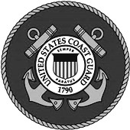

Cards shown are for illustrative purposes only. They are not actual card designs.
November Birthdays!

November 1
Harmony Letang

November 2 Aries Hindman Caylee Hultin
November 3
Joseph D. Jurenka Roger Schultz Brynn Walker
Wanda Warsinski

November 4 Caleb Blokzyl Nicholas Gochis Katya Peterson
November 5
Kathryn Mohs

November 7 Claudia Cook Kieran Ellwein Toni Wollan
November 9
Roy Bjornson Ethan Elvbakken

November 10 Shauna Eccleston Deborah Knudsen

November 11 Kathleen Blokzyl Violet Erdman Shawn Peterson
November 12
Katharine Antonick Joshua Miller

November 13 Casey Jones Dylan Klapmeier Donna Torgerson Richard Veach
November 14 Wyatt Deppmeier Diane Seiler
November 15
Lainee Hill
Joseph K. Jurenka

November 16 Olivia Mercer David Stockburger

November 17 Devon Lawson Tyler Northrup John Stelter
Ellie Stueve

November 18 Eileen Burns Karen Cable Danny Hartford
November 20 Cleo Anderson Lisa Large
November 21
Alexandria Klapmeier

November 22 Roger Anderson Janice Larison Paula Lavender
Aleigha Spatzierath
November 23
Tyler Eccleston

November 24 Alice Anderberg David Hill Mark Walker
November 25
Jacob Schmeltzer Ben Wareham
November 26
John Everson
November 27
Debbie Williams

November 28 Robert Clearman Cory Gunderson
November 30
Joan Fabricius

Happenings at First Lutheran School

Director Sue Taylor
Get, Set Teacher Hanna Hollatz
Pre-Kindergarten Teacher Lori Radtke
After School Care Julia Hollatz/Pam Worthy
Pastor Larry A. Miller

OUR GET, SET STUDENTS
Izzy, Daisy, Charli, Beckham, Knox, Kaden, Hendrix, Killian, Rhys, Eleanor, Roan and Zeke share some of their favorite fall time items and activities:

Trick-or-Treating, marshmallows,
hot dogs, leaves,
dressing up candy buckets, pumpkins,
hot chocolate with mini marshmallows, when the wind blows the leaves off the trees,
hot cocoa,
and hamburgers

OUR PRE-K STUDENTS

share some of their favorite activities when fall weather comes our way:
Archie: I like throwing the leaves up and throwing them on me!
Averie: I like to make a leaf pile and jump in it. It falls apart!
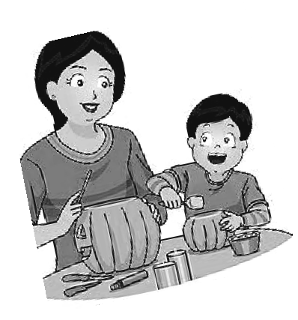Brayden: I like carving pumpkins. I got these things to carve them, like saws and stuff.
Charlotte: I get to play in the leaves and jump in them. That is really fun!
Emery: I make a tower with the leaves. I use a rake. Then I jump in it! It feels like ants.
Kamilah: I make angels. I lay in the leaves and do this...
Kylie: I like to jump in leaf piles. I also like to pick up leaves. When I jump it goes all over!
Kyson: I like the colors of the leaves. Orange is my favorite.
Sierra: I like leaves falling down. They fall like red.
Westyn: I like to jump in the leaf pile. It feels pretty nice!

First Lutheran Church & School 2231 Broadway
Helena, MT 59601
Phone: (406)442-5367
Fax: (406)442-5285
School Phone: (406)442-6913 Website: www.firstlutheranhelena.org
Email: churchoffice@firstlutheranhelena.org

NON-PROFIT ORG.
U. S. POSTAGE PAID
HELENA, MT PERMIT NO.
127
FIRST LUTHERAN CHURCH is a Congregation of The Lutheran Church—Missouri Synod
THE MISSION of First Lutheran Church is
“Sharing God’s Word with Everyone, Everywhere!”

Tune in to “The Lutheran Hour”—Sundays at 8 a.m. on the Christian Satellite Network 91.1-FM
or listen on “Family Talk” on Sirius XM 131
“Woman to Woman”—Sundays at 9:30 p.m. on KMTX 105.3-FM

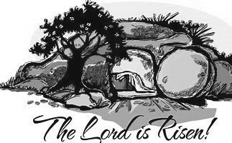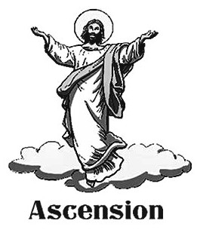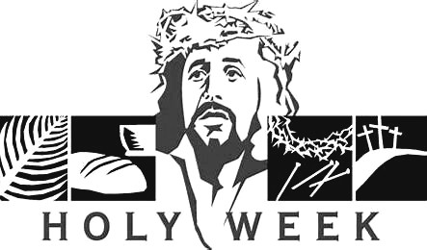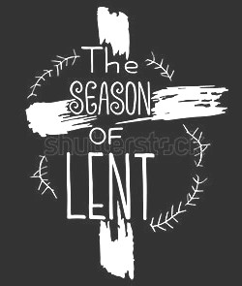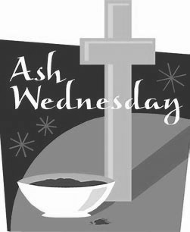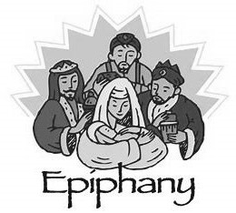The journey begins at Advent

“Like a great waterwheel, the liturgical year goes on relentlessly irrigating our souls, softening the ground of our hearts, nourishing the soil of our lives until the seed of the Word of God itself begins to grown in us, comes to
fruit in us, ripens in us the spiritual journey of a
lifetime.”
— Joan Chittister

When Advent begins on November 27 this year, so does a new church year for liturgical congregations.
The church seasons, which correspond to key events in Jesus’ life, begin with the four-week Advent period of preparation for our coming Savior at Christmas.
Following the 12-day season of Christmas is Epiphany, which begins January 6 and continues through Ash Wednesday, the
beginning of Lent.
The Lenten period of preparation
culminates in Holy Week, and then Easter marks the pinnacle of every church year.
Forty days after the Resurrection we
celebrate Ascension, and 10 days after that, the Pentecost season begins; it lasts until Advent, when the cycle begins anew.

